P.Mani Sai

2303A54052 B-47B
Lab 1
Assignment Number 1.3

TASK:1
PROMPT: Write a Python program that asks the user for a number and prints the Fibonacci sequence up to that number, without using any functions
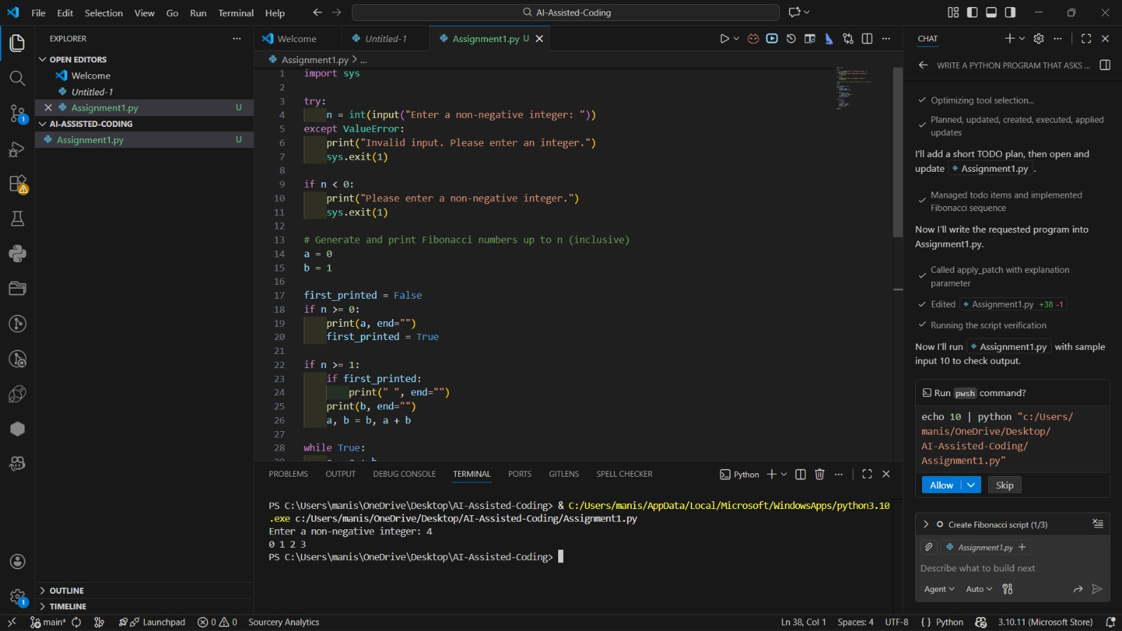

TASK:2
PROMPT: Optimize this code
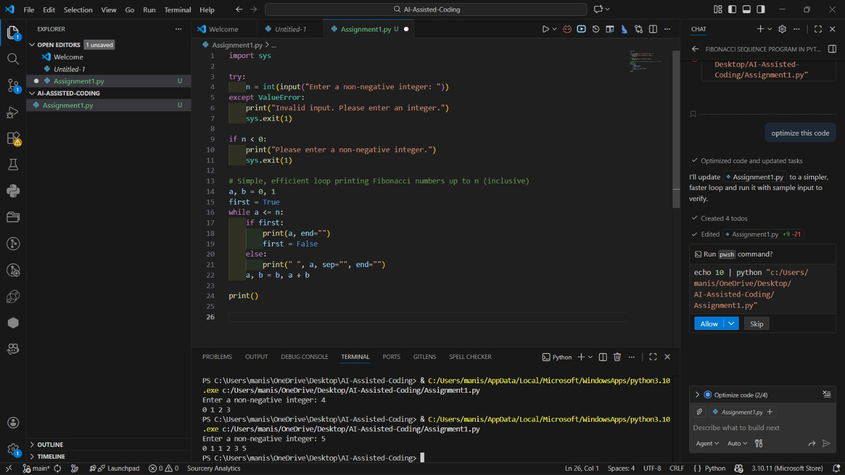

TASK:3
PROMPT: Generate a Python program that uses a function to print the Fibonacci sequence and asks the user for a number.
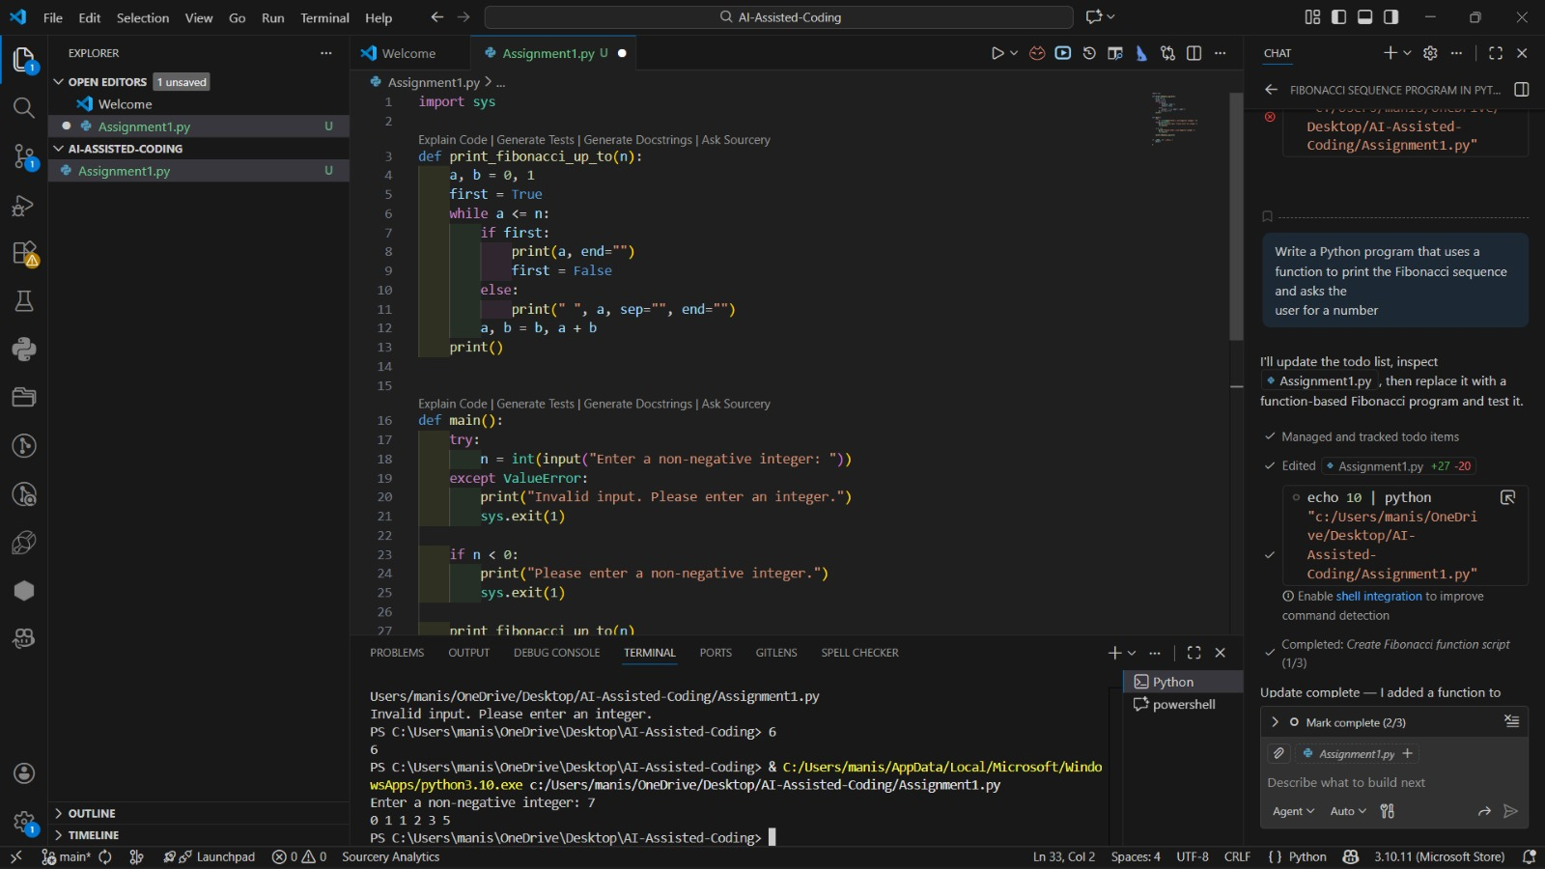

TASK:4
PROMPT: Print Fibonacci code with functions and without functions. Analyze code clarity, reusability, debugging ease, and suitability for large systems.
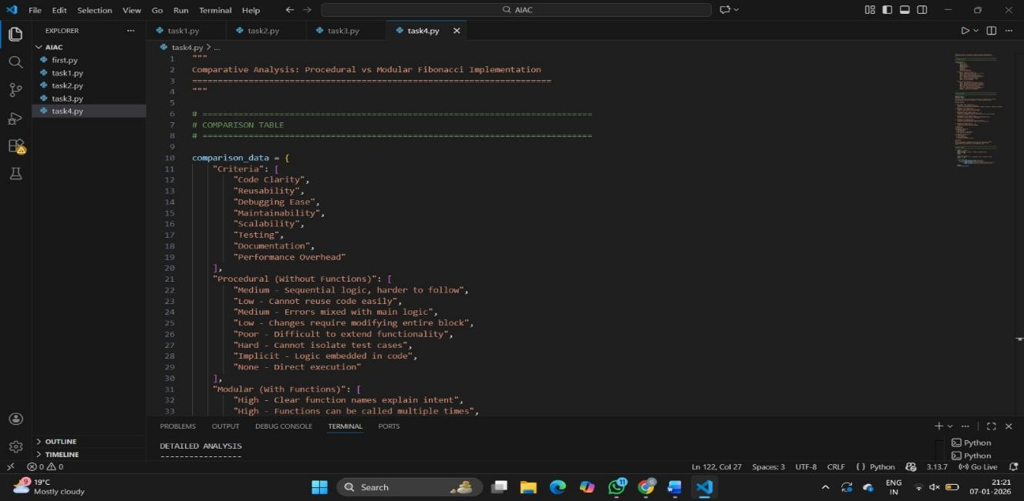
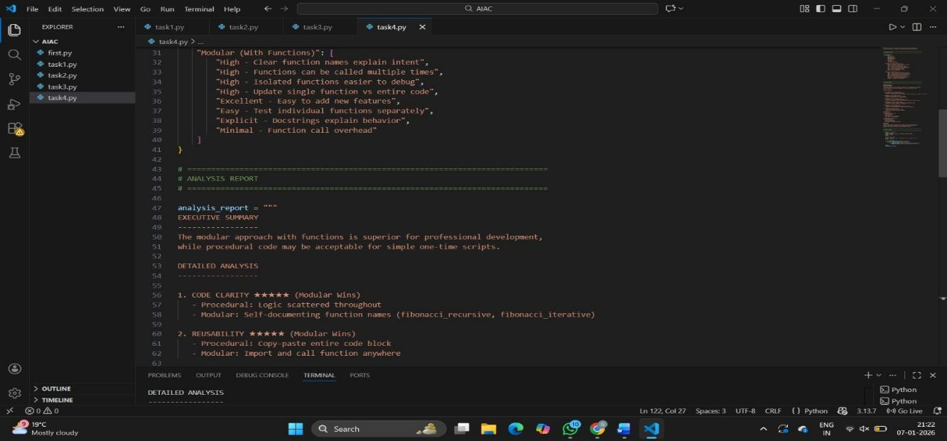
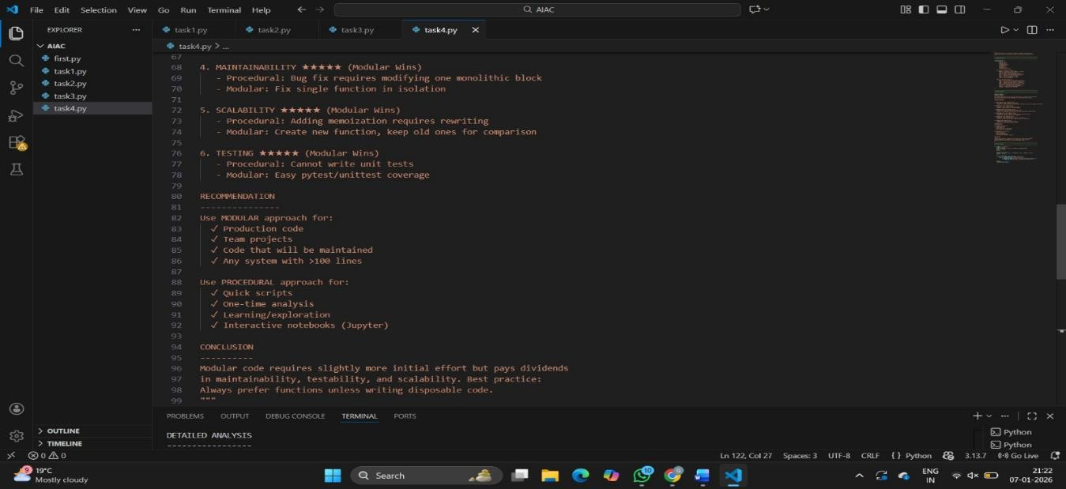

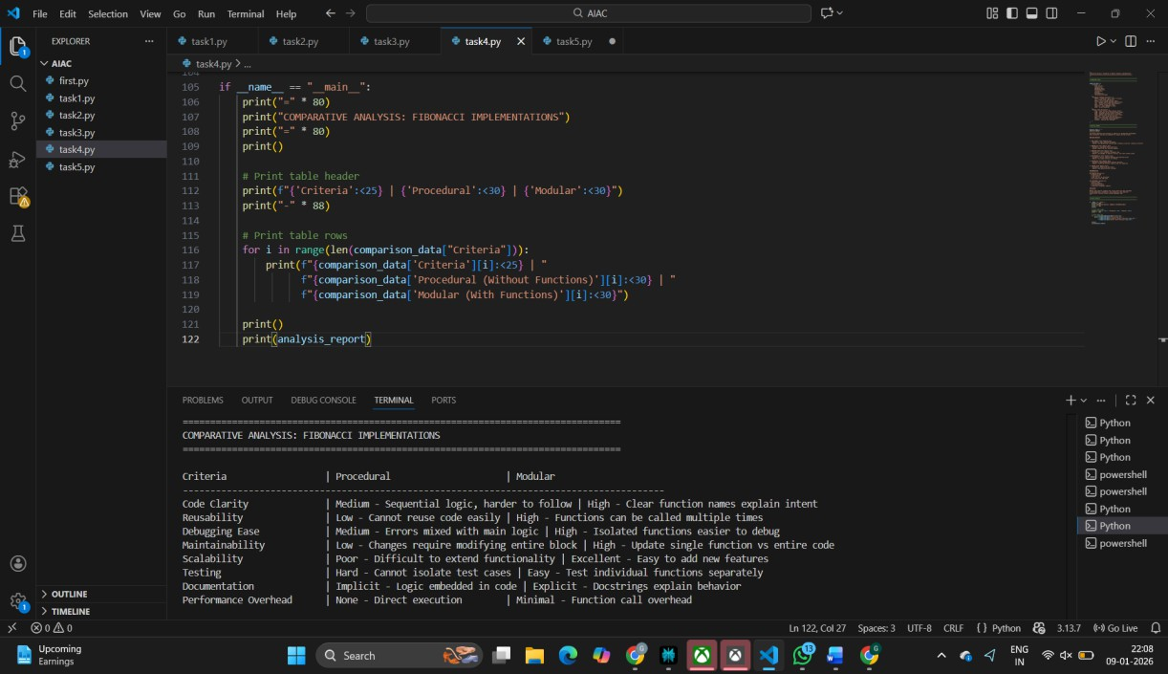

TASK:5
PROMPT: Generate an iterative Fibonacci implementation, recursive Fibonacci implementation compare their time complexity, performance for large n
